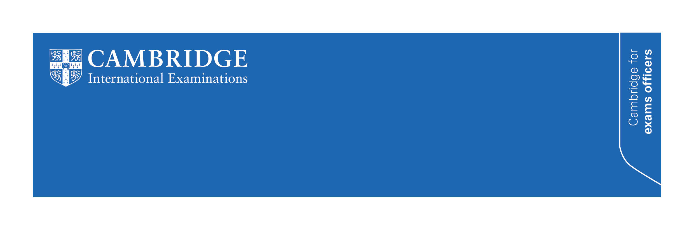
Administering Cambridge IGCSEs in English
for UK schools, June 2016

This communication is for UK schools entering candidates for the following syllabuses in June 2016:

- Cambridge IGCSE English – Literature (0486)
- Cambridge IGCSE English – First Language (0500)
- Cambridge IGCSE English – First Language (UK) (0522).
It is important that you share this communication with Heads of English and English teachers at your school.
UK entries for Cambridge IGCSEs in English have grown considerably in recent years. For new schools in particular, making the transition from familiar UK exam regulations to the regulations of an international exam board can sometimes be challenging. This communication will help you better understand the requirements of the above syllabuses.

Approaches to 0500/0522 Paper 02, Reading Passages (Extended)
Centres should be aware of the following responses to common queries about this question paper.

Word length | Examiners do not apply a penalty to candidates who do not meet the requirements of word length on any of the questions on this paper (or on any other paper within the 0500 or 0522 syllabus). Where candidates do not meet the word length for each question, however, they may penalise themselves – often through a lack of development or for a loss of control of their writing.
Question 2 | For question 2 we remind Centres that a formulaic approach to responding to powerful words and phrases is not recommended and is often limiting for candidates. We also remind Centres that candidates should reflect on the use of the selected language within the context of the passage.
Question 3(a) | For question 3(a) we remind Centres that candidates are assessed on assessment objectives R1, R2 and R3 and there is an expectation of precision in regard to candidates’ selection of points. Whilst candidates are not expected to use their own words, they do need to be careful to carry the precise meaning of what is expressed in the passage.

Mark adjustments in moderated components
Coursework and speaking and listening components are marked and internally moderated within the school. We then moderate the marks externally. As with all syllabuses, we may adjust your candidates’ marks as part of this process. The marks that you send us may not be the candidates’ final marks. If you are giving your internally assessed marks to students or parents, please make sure they understand that the marks are not final.

Enquiries about results: re-moderation
In components where we moderate the marks, you may want to query any adjustments we make by submitting an enquiry about results (service 5). This service is not available for individual candidates and can only be used for a whole cohort. Any mark adjustments we make will be applied to all candidates and their grades may go up or down. You will need the candidates’ consent before submitting an enquiry about results.
Tolerances in moderated components
Unlike some other exam boards, we do not use tolerances in deciding the mark adjustments we make to moderated components. We will make an adjustment even if a school’s marking is one mark from the agreed standard. This means that we make adjustments more frequently than some other exam boards. If we make small adjustments to your marks, this is a sign of the rigour of our moderation processes rather than a reflection on your marking.

Sampling arrangements for external moderation
We emailed you about our sampling arrangements in the March 2016 edition of Cambridge Exams Officer eNews.

Internally assessed marks | The deadline for submitting internally assessed marks for Cambridge IGCSE First Language English and English Literature is earlier than last year: 27 April 2016.
Speaking and listening components | For Cambridge IGCSE First Language English speaking and listening components (0500/05, 0500/06, 0522/05, 0522/06) you must send us all your candidates’ recordings for external moderation. Your recordings must arrive by 30 April 2016.
Coursework components | For coursework components (including 0486/05, 0500/04 and 0522/04), we will upload the list of candidates whose work we want to see to the ‘My Messages’ section of CIE Direct approximately two working days after we have received and processed your marks. Your samples must arrive by 30 April 2016. Submitting your marks as early as possible will give you more time to prepare your sample.

Dates for speaking and listening tests, June 2016
Components 0500/05 and 0522/05 are speaking and listening tests. They must take place from
1 March to 26 April 2016. We may not accept candidates’ marks if you run the tests outside this period. If you conducted the tests before 1 March, please contact our Customer Services team straight away (info@cie.org.uk).

Using scripts and cue cards in speaking and listening tests
Please read our guidance on using scripts and cue cards in components 0500/05 and 0522/05. Before the tests candidates need to know what they are allowed to bring into the exam room. To summarise the guidance in the syllabus:

- scripts are not allowed in the exam room
- candidates are allowed a single cue card each and these cue cards may contain key points, but must not contain any prose or complete sentences
- cue cards should contain no more material than would fit onto a standard postcard
- candidates may bring a picture or other prop into the exam room, but these may not contain any text
- teachers may offer guidance on the suitability of the topic, but must not have any involvement in preparing materials.

Our moderators are trained to recognise when candidates are reading aloud. We may ask you to send us the cue cards if we suspect that candidates are reading from them. We also ask Centres to advise candidates that rote-learned and recited material is unlikely to score well as we award marks for their interaction with the examiner conducting the test.

Recording of speaking and listening tests
Speaking and listening tests are designed to be recorded in an audio format and we do not recommend that Centres submit video recordings of candidates.

Using templates in the Coursework Portfolio
In components 0500/04 and 0522/04, do not allow candidates to use templates or other structuring materials to assist them in their writing. This is because we award some marks for the candidate’s ability to structure their work. Using templates and other structuring materials constitutes an attempt to pass off the template author’s structural work as the candidate’s and will be considered as malpractice.

Using electronic devices in Open Book components
Component 0486/32 is an open text exam. This means that candidates may take the books they have been studying into the exam. These books must be paper copies. Candidates are not allowed to bring Kindles, tablets or other e-readers into the exam room, even if this is what they have been using during their course of study.

Predicted grades
Teachers need to be able to predict candidates’ grades both for progress tracking purposes and to submit to Cambridge as forecast grades. To help teachers with this task we publish grade descriptions in the syllabuses. These are the most effective way to predict grades from candidates’ work. We also publish the grade boundaries of examination papers, which are useful if you use past papers for mock examinations. From the June 2016 series onwards we will also publish the grade boundaries for moderated components.

Further support
If you are unsure about any of our regulations, please contact our Customer Services team at info@cie.org.uk or on 01223 553554. Checking with us first will help you to avoid making common administrative errors which could lead to a malpractice enquiry or delay the release of results to your candidates.

A guide for UK schools: Administering Cambridge IGCSE First Language English (0500 and 0522)  This guide is available from the syllabus pages of our website (www.cie.org.uk/igcse). We encourage you to read it as it contains detailed information for exams officers administering these syllabuses. | 